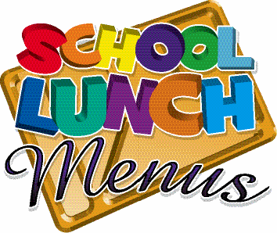
WEEK 1 (April to July 2024)

 | MONDAY | TUESDAY | WEDNESDAY | THURSDAY | FRIDAY
MAIN DISH | Tuna & Sweetcorn  Pasta Bake  Garlic Bread  Mixed Veg | Jacket Potato  Grated Cheese  Baked Beans | Roast Turkey & Stuffing  Roast potatoes  Broccoli, Carrots  Gravy | Jamaican Jerk  Chicken  Steamed Rice  Sweetcorn | Fish Cake  Chips  Baked Beans
MAIN DISH  HALAL | Tuna & Sweetcorn  Pasta Bake  Garlic Bread  Mixed Veg | Jacket Potato  Grated Cheese  Baked Beans | Roast Turkey & Stuffing  Roast potatoes  Broccoli, Carrots  Gravy | Jamaican Jerk  Chicken  Steamed Rice  Sweetcorn | Fish Cake  Chips  Baked Beans
MAIN DISH  VEGETARIAN | Tomato Vegetable  Pasta Bake  Garlic Bread  Mixed Veg | Jacket Potato  Grated Cheese  Baked Beans | Quorn Roast  Roast potatoes  Broccoli, Carrots  Gravy | Jamaican Quorn  Steamed Rice  Sweetcorn | Southern Style  Quorn Burger  Chips  Baked Beans
DESSERT | Apple Crumble  Custard | Carrot  Cake | Raspberry Ripple  Ice-Cream Roll | Lemon  Cheesecake | Fresh Fruit  Salad

MENU IS SUBJECT TO CHANGE SHOULD INGREDIENTS BE UNAVAILABLE

