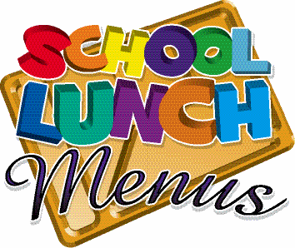
WEEK 2 (April to July 2024)

 | MONDAY | TUESDAY | WEDNESDAY | THURSDAY | FRIDAY
MAIN DISH | Fish Fingers  Herby Diced Potatoes  Sweetcorn | Beef Bolognese  Spaghetti  Peas | Roast Chicken & Stuffing  Roast potatoes  Carrots, Peas  Gravy | Chicken Wrap  Savoury Mixed Rice  Mixed Salad | Pizza  Chips  Baked Beans
MAIN DISH  HALAL | Fish Fingers  Herby Diced Potatoes  Sweetcorn | Beef Bolognese  Spaghetti  Peas | Roast Chicken & Stuffing  Roast potatoes  Carrots, Peas  Gravy | Chicken Wrap  Savoury Mixed Rice  Mixed Salad | Pizza  Chips  BBQ Baked Beans
MAIN DISH  VEGETARIAN | Southern Style  Quorn Burger  Herby Diced Potatoes  Sweetcorn | Vegetarian Bolognaise  Spaghetti  Peas | Quorn Roast  Roast potatoes  Carrots, Peas  Gravy | Veggie Quorn Wraps  Savoury Mixed Rice  Mixed Salad | Southern Style  Quorn Burger  Chips  Baked Beans
DESSERT | Fruit  Meringue | Jam Sponge  Custard | Fruity Chocolate  Traybake  Cream | Somerset Apple  Cake | Ice Cream  Tub

MENU IS SUBJECT TO CHANGE SHOULD INGREDIENTS BE UNAVAILABLE

